|  |
| --- |
| **1. Build a branching model to help your team understand the Git workflow for faster integration of work.** |

# Configure Git user

# Set global Git username and email

git config --global user.name

git config --global user.email

# Create and initialize a new Git repository

# Create directory 'practical', navigate to it, and initialize a Git repository

mkdir practical

cd practical

git init

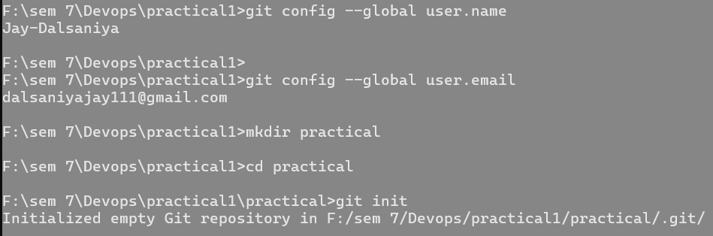

# Add files and commit

git add welcome.html

# Add welcome.html to staging area and check status

git status

git add .

# Add all files to staging area and check status

git status

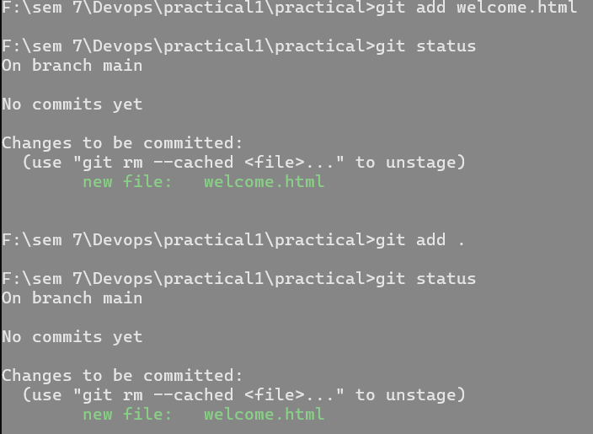

# Commit changes with a message

git commit -m "This Is First Commit"

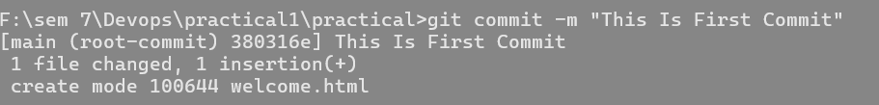

# View logs and manage branches

# View commit logs

git log

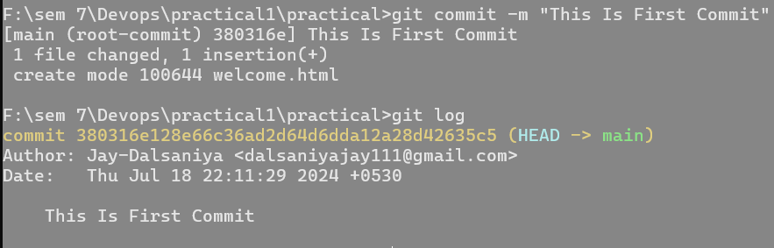

# List branches

git branch

# Create a new branch named 'jay_dalsaniya'

git branch jay_dalsaniya

# Create and switch to ‘jayu’

git checkout -b jayu

# List branches

git branch

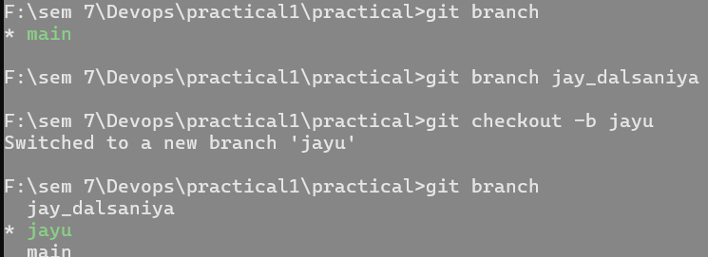

# Check the status of the working directory

git status

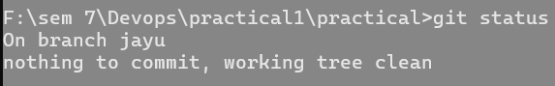

# Checkout to jay_dalsaniya branch and merge branches

# Switch to 'jay_dalsaniya' branch

git checkout jay_dalsaniya

# Merge ‘jayu’ into 'jay_dalsaniya'

git merge jayu

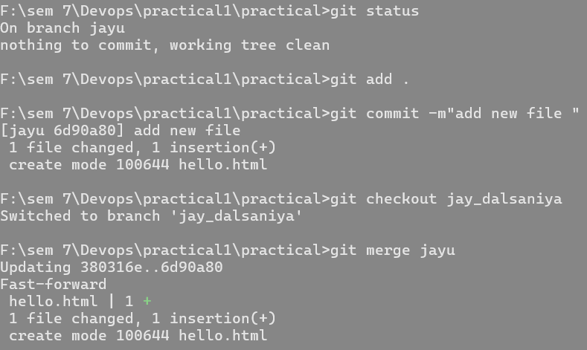

# Delete ‘jayu’

git branch -d jayu



# Add remote repository and push to GitHub

# Add remote GitHub repository

git remote add origin https://github.com/Jay-Dalsaniya/github_practices-.git

# Push changes to the 'master' branch on GitHub

git push -u origin main

